❄️ Arctic-Shield Simulation Results (English Version)
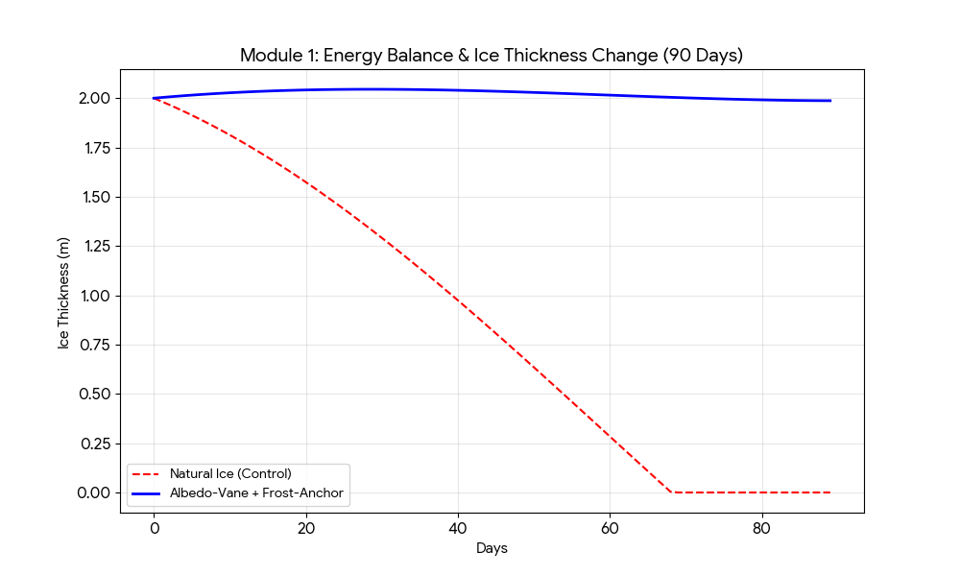
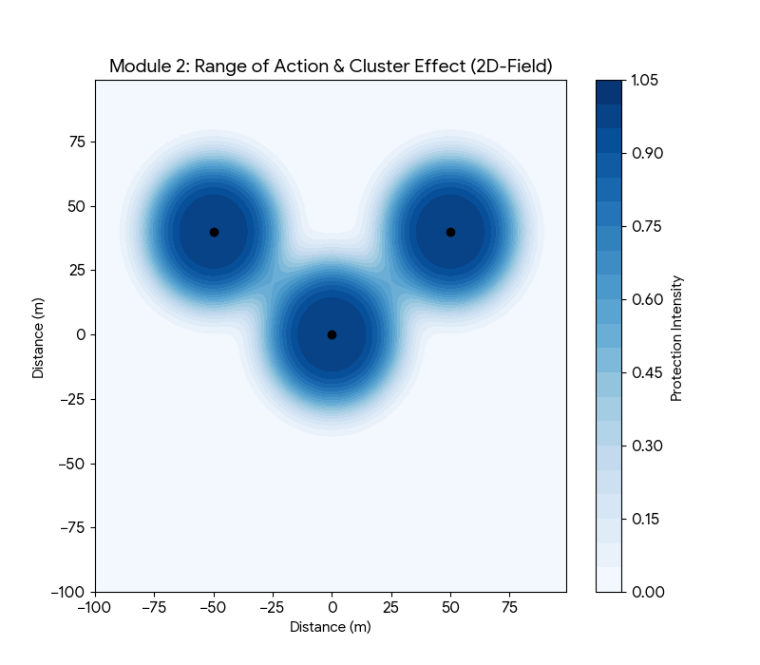

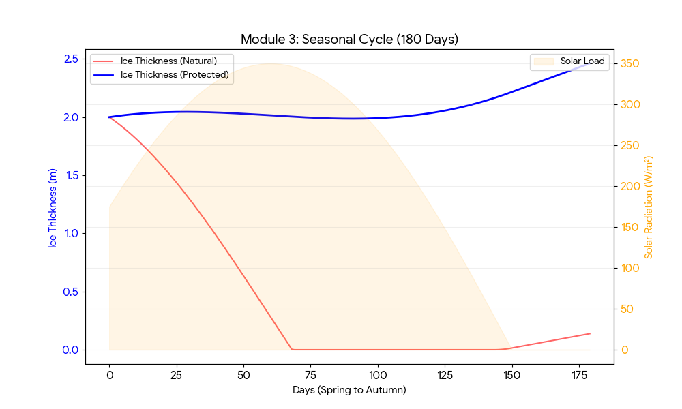
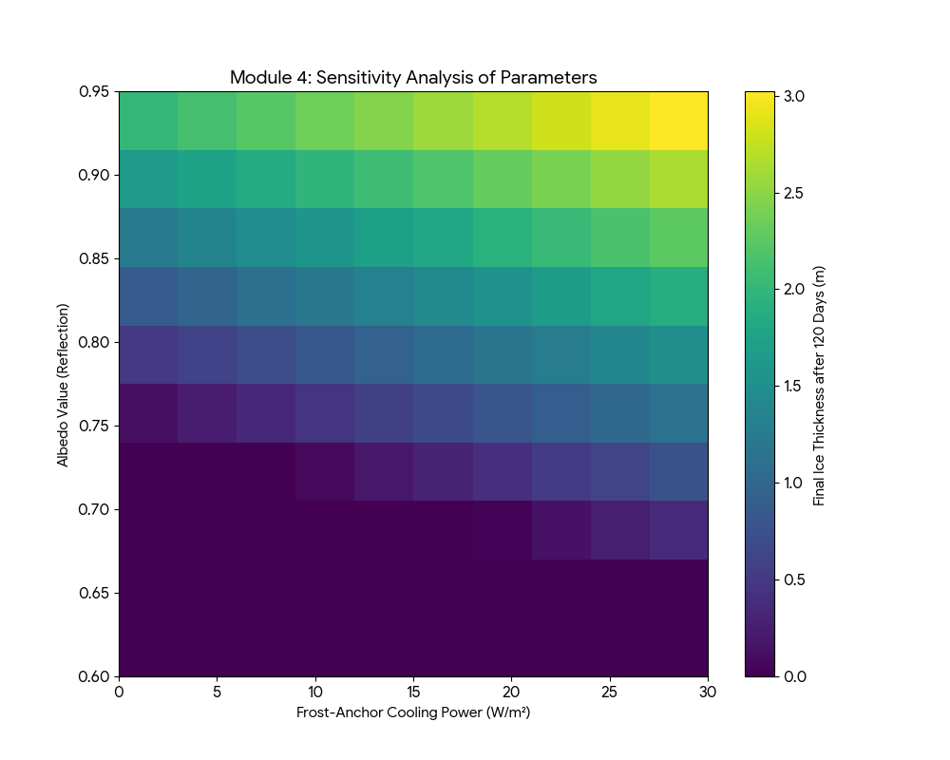

1. Energy Balance & Ice Thickness Change
This chart illustrates the performance over a 90-day peak melt period.
- Natural Ice (Red dashed): Shows a significant decline in thickness due to solar absorption.
- Albedo-Vane + Frost-Anchor (Blue): Demonstrates a stabilization and slight growth of the ice layer, creating what we call the "Ice Fortress."

2. Range of Action & Cluster Effect
This 2D field model visualizes the spatial protection intensity.
- Each black dot represents a station.
- The overlapping zones (Clusters) show how multiple units create a reinforced, continuous shield of stabilized ice, significantly increasing the collective efficiency compared to isolated units.

3. Seasonal Cycle (180 Days)
This simulation covers the transition from spring through the high-intensity polar summer into autumn.
- The Solar Load (orange) peaks mid-cycle, yet the protected ice thickness remains resilient.
- You can clearly see the "synergy effect": the Albedo-Vane blocks the heat from above, while the Frost-Anchor handles the residual thermal energy from the water.

4. Sensitivity Analysis
A key tool for Auron's optimization.
- This heatmap reveals the relationship between Reflection (Albedo) and Cooling Power (Frost-Anchor).
- It identifies the "Goldilocks zone" (the yellow/bright area) where the combination of parameters leads to maximum ice preservation, allowing for precise calibration of the material deployment and thermosiphon depth.

These English-language graphics are now ready for your master report or any global presentations of the project.

